Metadata and linking images to text
One of the most important steps in creating a multimodal RAG system is connecting images to text. Technical manuals typically contain a large number of illustrations, labels, tables, and other visual aids meant to highlight specific textual passages. These images convey extremely important information and must be appropriately connected to the instructions or phrases they depict.
Otherwise, the system will handle text and images separately if they are not correctly linked. Therefore, the RAG system may just retrieve the written explanations and not give the supporting diagrams when a query calls for some kind of visual context, such as wiring diagrams, component layout, safety symbols, or step-by-step drawings. This will compromise the manual's informational integrity.
In order for the RAG system to receive both text and images simultaneously, accurate linkage ensures that each visual component stays linked to its pertinent content. Building a dependable multimodal retrieval system that can handle intricate, technical, and instruction-rich materials requires this.

Metadata and Linking images to texts
- Metadata organizes the document’s structure
  - It records essential information such as page numbers, section titles and element positions. This creates a clear map of how every part of the document is arranged.
- Metadata links text chunks to related visual content
  - Text blocks can be connected to diagrams, images or captions using shared attributes like page location or bounding boxes. This ensures that descriptions and visuals stay paired together.
- Metadata keeps tables aligned with their context
  - Tables often summarise or expand on nearby text. By storing table specific metadata, such as extraction coordinates and associated section headings, the system knows exactly where the table belongs and what it supports.
- Metadata captures page layout information
  - Details about the layout help maintain the original flow of information so the system retrieves content in a meaningful sequence.
- Metadata enables precise context aware search
  - When all elements are properly connected, a query can trigger retrieval of both text and relevant image, table or diagram. This significantly improves the accuracy of multimodal RAG systems.
Implement Approach
Phase 3 of this projects document processing procedure now includes metadata generation and image text pairing. After the PDF manuals are parsed, the text is retrieved and divided into manageable chunks for embedding. Images are retrieved on a different location with names that includes details about the original document and page.
Each text chunk then has metadata created for it, including chunk identification, page citation, and the name of the original document. Text and image elements can be connected using the previously mentioned metadata elements. This ensures that both components are connected throughout the whole process.
The succeeding process, such as vector representation, similarity search in multimodal content and RAG answer generation are made easier by this logical handling of the input.
Linking Strategy used in this project
Page level metadata linking is the main linking technique used in the project in concern. The text passages that come from the same page in the original PDF are linked to each extracted image. This is a practical and effective method of preserving text visual contextual alignment without needlessly increasing computational complexity.
Technical manuals, which typically arrange their diagrams and graphics adjacent to the instructions or descriptions they illustrate, prove to be especially well suited for page level linking. This basic approach provides good baseline performance and simplicity, but it could miss fine grained interactions in documents with dense layout.
This might be expanded to include coordinate-based linking which uses positional data to link images to nearby text or semantic linking, which uses multimodal embeddings like CLIP to link images to important text chunks based on meaning rather than layout.
Testing

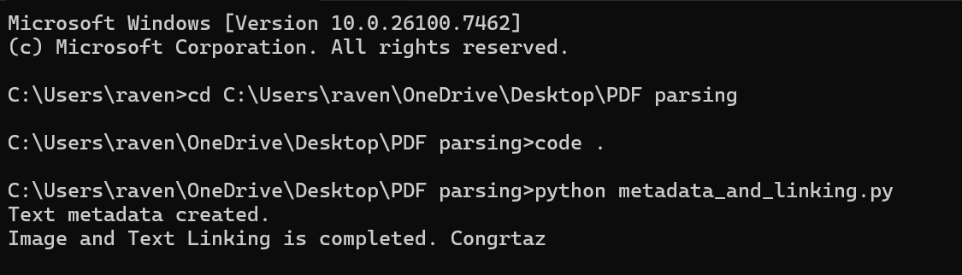
Figure 1: Creating the link between Image and Text
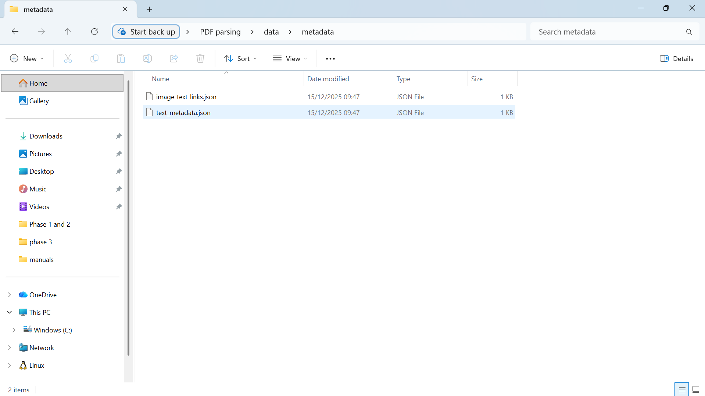
Figure 2: Links being created in the folder
The working code
To generate structured metadata for text segments and link photos to related content based on a page level correlation, a single Python script has being used. The Python script creates a JDON file for later multimodal RAG learning after receiving inputs from the parsing of PDF files and chunking of texts.

